1-File
# Source: AI Source: Provided by: [Data Path: Persons Table -> ID Column: 1, Name_En Column: Motasem Essam] -> From: [Chatgpt (GPT‑5 Mini)] on [1/26/2026]
The term “file” can mean different things depending on the context, but in computing, a file is a collection of data or information stored on a computer under a specific name. It is the basic unit of storage in a computer system. Files can contain text, images, audio, video, programs, or any other type of digital information.
Here’s a more detailed breakdown:

Structure:
# Source: AI Source: Provided by: [Data Path: Persons Table -> ID Column: 1, Name_En Column: Motasem Essam] -> From: [Chatgpt (GPT‑5 Mini)] on [1/26/2026]
  - A file usually has a name and an extension (like .txt, .jpg, .mp3) which indicates the type of file.
  - Example: document.txt → document is the name, .txt is the extension indicating it’s a text file.

Types of Files:
# Source: AI Source: Provided by: [Data Path: Persons Table -> ID Column: 1, Name_En Column: Motasem Essam] -> From: [Chatgpt (GPT‑5 Mini)] on [1/26/2026]
  - Text files – contain readable text (.txt, .csv).
  - Binary files – contain data in a format only a program can interpret (.exe, .jpg, .mp3).
  - Executable files – files that can run programs (.exe, .bat).
  - System files – used by the operating system (.dll, .sys).

EXAMPLES
# Source: AI Source: Provided by: [Data Path: Persons Table -> ID Column: 1, Name_En Column: Motasem Essam] -> From: [Chatgpt (GPT‑5 Mini)] on [1/26/2026]
  - Notes.txt
  - Resume.docx
  - Vacation.jpg
  - Song.mp3
  - Movie.mp4 •
  - Game.exe •

Purpose:
# Source: AI Source: Provided by: [Data Path: Persons Table -> ID Column: 1, Name_En Column: Motasem Essam] -> From: [Chatgpt (GPT‑5 Mini)] on [1/26/2026]
  - Files are used to store information so it can be retrieved and used later.
  - They allow the organization of data in a permanent, reusable way.

Storage:
# Source: AI Source: Provided by: [Data Path: Persons Table -> ID Column: 1, Name_En Column: Motasem Essam] -> From: [Chatgpt (GPT‑5 Mini)] on [1/26/2026]
  - Files are stored on storage devices like hard drives, SSDs, USB drives, or cloud storage.
  - They are usually organized into folders/directories for easier management.
In short: a file is like a digital container for information.

2-Folder
# Source: AI Source: Provided by: [Data Path: Persons Table -> ID Column: 1, Name_En Column: Motasem Essam] -> From: [Chatgpt (GPT‑5 Mini)] on [1/26/2026]
A folder (also called a directory) is a container used to organize and store files and sometimes other folders on a computer. Think of it like a physical folder in a filing cabinet where you keep papers: it doesn’t hold the content itself but keeps things organized.
Here’s a clear breakdown:

Purpose:
# Source: AI Source: Provided by: [Data Path: Persons Table -> ID Column: 1, Name_En Column: Motasem Essam] -> From: [Chatgpt (GPT‑5 Mini)] on [1/26/2026]
  - To organize files so you can find and manage them easily.
  - To group related files together.

Structure:
# Source: AI Source: Provided by: [Data Path: Persons Table -> ID Column: 1, Name_En Column: Motasem Essam] -> From: [Chatgpt (GPT‑5 Mini)] on [1/26/2026]
  - A folder can contain:
    - Files (like documents, images, videos, etc.)
    - Subfolders (folders inside a folder, also called nested folders)
  - Example:
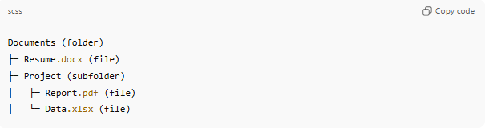
  - Documents (folder)
  - ├─ Resume.docx (file)
  - ├─ Project (subfolder)
  - │ ├─ Report.pdf (file)
  - │ └─ Data.xlsx (file)

Difference Between a File and a Folder:
# Source: AI Source: Provided by: [Data Path: Persons Table -> ID Column: 1, Name_En Column: Motasem Essam] -> From: [Chatgpt (GPT‑5 Mini)] on [1/26/2026]
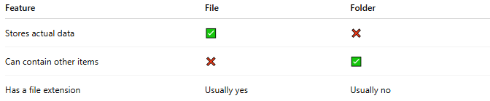
Feature | File | Folder
Stores actual data | ✅ | ❌
Can contain other items | ❌ | ✅
Has a file extension | Usually yes | Usually no

Storage:
# Source: AI Source: Provided by: [Data Path: Persons Table -> ID Column: 1, Name_En Column: Motasem Essam] -> From: [Chatgpt (GPT‑5 Mini)] on [1/26/2026]
  - Like files, folders are stored on hard drives, SSDs, USB drives, or cloud storage.
  - They help keep your digital workspace neat and organized.
In short: a folder is a digital container used to organize files and other folders.

